3D print Insufficient fill
The filled part of the 3D print plays a very important role in increasing the strength of the model. In 3D printing, the shell responsible for connecting the outer layers is filled and at the same time the outer surface to be printed on is also supported. If the fill is not strong or slender, you need to adjust a few settings in the software to enhance this section.
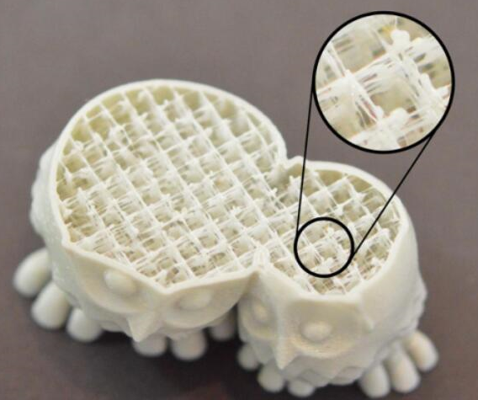

Reduce print speed
In the 3D printing process, the filling speed is usually faster than that of other parts. If you try to make the print speed too fast, the extruder will probably not keep up. In the model, there will be insufficient discharge. This lack of discharge will produce a weak, slender filling because the nozzle cannot squeeze out enough consumables as software expects. If you've tried several fill textures, but still aren't filled, try reducing the print speed. Adjust the "Default print speed", this parameter directly determines the speed used when filling. For example, if you previously printed at 60mm/s, try reducing this value by half to see if the fill starts to get more solid.
Increase the width of filled extrusion wire
A very useful feature of CURA 2.7.0 is that it can modify the width of the extruded filaments used to fill the printouts. For example, you can use 0.4mm of extruded filament width to print the periphery, but you can use 0.8 for the width of the extruded filament for filling. This will create a thicker, more solid fill wall, which may increase the strength of the 3D print. Modifying this setting can be adjusted in Print Settings - Quality - Width (Fill). "The width of the trace (fill)" is determined by the size of the nozzle's aperture. For example, a nozzle width of 0.4 is 0.4 mm, which is generally set as an integral multiple of the nozzle. One thing to remember: When you adjust this setting, the software will maintain the fill rate you set. So if you set the fill width to 2 times the nozzle, each fill line will use twice as much consumables. In order to maintain the same fill rate, the distance between fill lines will become far. As a result, many users tend to increase the fill rate after increasing the width of the filled extruded wire.

