3D printer filament planner solution
Most 3D printers use a pinion gear and another bearing to clamp the filament so that the gear catches it. Drive gears have sharp teeth that can bite into the filament, and then rely on the direction of rotation of the gear to move the filament back and forth. If the filament does not move but the gear continues to rotate, the gear may shave off some of the plastic from the filament so that the gear has no place to catch the filament. Many people call this situation " planner." Because too much consumable was shaved, the extrusion function was abnormal. If this happens to your printer, you will often see lots of plastic debris scattered across the floor. You will also see that the extruder is spinning, but the consumable has not been pushed inside the extruder. In the following we will introduce the easiest way to solve this problem.
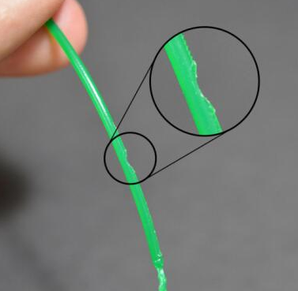

Increase printing temperature
If you have been encounter the problem like that, try to increase the temperature of the nozzle by 5 to 10 degrees so that the plastic extrusion is easier. You can modify the print temperature settings. There is a printing temperature in the basics. When you slice, you can set a new one and print it in a slice. Plastics are always easier to extrude when the temperature is high, so this is a very useful setting that can be adjusted.
Print speed is too fast
After raising the temperature, if you still have problems with the grit, the next thing you need to do is reduce the print speed. By doing so, the motor of the extruder does not have to be rotated at such a high speed, because the filament takes longer to squeeze out. Reducing the motor speed of the extruder helps to avoid the problem of the grit. For example, if your previous print speed is 3600mm/min (60mm/s), try reducing this value by one-third to see if the problem with the grit has disappeared.
Check if the nozzle is clogged
After reducing the temperature and printing speed, if you still have problems with the flake, the nozzle may be clogged. Then you need to clean up the nozzle. First, if the plugging is not serious, consumables will be intermittent, then you raise the printing temperature to 230 degrees, then use a small needle to spray several nozzles, then manually feed it out to see Whether or not the material can come out normally. If it does not work, then you can replace a new nozzle. Then clean up the inside of the pipe and check if the pipe is normal or not. Sometimes you need to replace it with a new one.
Teflon tube carbonization in the throat
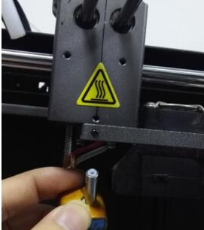

There is a small section of Teflon tube in the throat of the machine. The Teflon tube is resistant to high temperatures, but the Teflon tube will gradually be carbonized when working in a high temperature environment for a long time, resulting in a relatively small Teflon tube. The narrowing of the channel causes subsequent extrusion to be unsmooth, resulting in a phenomenon of insufficient material and card material. To extract the Teflon tube in the heated state, if there is carbonization, it can be cut for a long one and then replaced.

