3D printing middle dislocation solution
Most 3D printers use open-loop control systems. To put it bluntly, they have no feedback on the actual position of the nozzle. The printer simply tries to move the nozzle to a location and hopes it can get there. Most of the time, this is feasible because the stepper motor that drives the printer is very powerful and there is no huge load to stop the nozzle from moving. Then if there is a problem, the printer will have no way to find it. For example, when printing, you suddenly hit your printer and you may cause the nozzle to move to a new location. The machine has no feedback to identify this situation. So, it will continue to print as if nothing had happened. If you find that the layer in the printer is misaligned, it may be due to one of the reasons listed below. Unfortunately, once these errors occur, the printer has no way to find problems and deal with problems. So we will explore how to solve this problem.
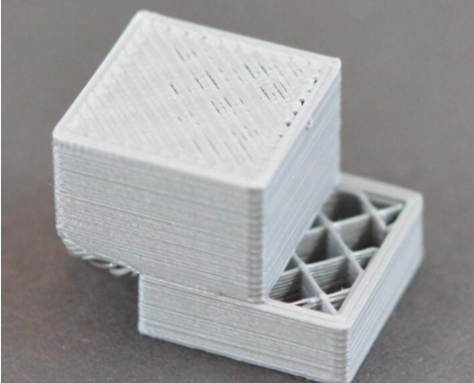

The nozzle moves too fast
If you print at a very high speed, the 3D printer's motor will do its best to support it. If you try to print at a faster rate than the motor can tolerate, you usually hear a squeaking noise and the motor cannot turn to the desired position. In this case, the next printed layer will be misaligned with all previously printed layers. If you think your printer is printing too fast, try reducing the print speed by 50% to see if it helps. If you still want the model to continue printing during the printing process, you can directly rotate the knob to adjust the printing speed of the model, that is, the rate (FR100%) can be appropriately reduced.
Nozzle scraped into the model during printing
Sometimes the nozzle will scratch the model during the printing process, especially during the translation from one position to another. After reaching the position, the nozzle does not have any lifting process and it will stick directly to it, which is very easy to scratch the model. , but the machine itself is not sensing, so the nozzle will continue to work, but the printed model may have been misplaced, then you need to find the tool in the slice, open the expert settings inside, set the Z axis on the back Raising the height and raising the height of the appropriate Z axis can prevent the nozzle from scratching the model and causing misalignment. It can be set at 0.3.
Model problem
There are many methods for the source of the model, you can download it online, you can model it yourself, or you can use the scanner to reverse model; The model downloaded online is easy to go wrong, it looks good when you download it, but after it comes out , there will be a lot of wired problems. Including the wrong layer. after the slice is completed there is a preview of the layer, you can preview the layers, check if every layer is normal, if at any level suddenly went out The root line, then this model is definitely problematic. The normal model preview is that the nozzle trajectory of each layer is moving around the model, so this you can check after each layer is cut to ensure that the model itself is not questionable.

Affected by external forces

The machine itself is driven by the belt driven by the motor. A small external force may affect the movement of the nozzle, causing the motor to lose its stride, or the size of the model beyond the forming platform when slicing, causing the nozzle to lose step at the most edge of the platform will also cause Split level. So try not to have other irrelevant items or human interference next to the printer.
Mechanical problem
If you reduce the speed, misalignment problems still occur, it is possible that your printer has mechanical or electronic problems. For example, most 3D printers use a sync drive to drive the motor to control the position of the nozzle. Timing belts are usually made of rubber and reinforced with some sort of fiber. If used for a long time, the timing belt may be loosen, thereby affecting the tension of the timing belt nozzle. If the tension is not enough, the timing belt may slip on the synchronizing wheel, which means that the synchronizing wheel has turned, but the timing belt has not moved. If the timing belt is installed too tightly, it can cause problems. Excessively tightened timing belts can create excessive friction between the bearings, thus preventing the motor from rotating. Ideally, the belt is tight enough to prevent slippage but not so tight that it hinders system operation. If you are dealing with misalignment, you need to make sure that the tension of all timing belts is appropriate and not too loose or too tight. If you think there may be a problem, you can adjust the passive pulley of the belt to adjust the tightness of the timing belt.
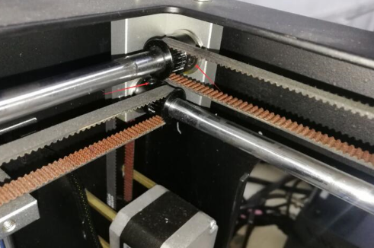

Check whether the synchronous wheel above the motor is locked, because the synchronous wheel is fixed on the motor shaft by two top screws. If the top screwsof the synchronous wheel is loose, the motor will run away, causing a lost step and the model will be misplaced. The solution for this is very simple, just print a simple model after locking the top screws.

