3D printing temperature overheating
The plastic extruded from the extruder is at least 190 to 240 degrees Celsius. When the plastic is still hot, it is still soft and can be easily molded into different shapes. Then, when it cools, it quickly becomes solid and set. You need to achieve a normal balance between temperature and cooling, so that filament can smoothly flow out of the nozzle, but it can quickly solidify to get the print size accuracy. If you can not reach balance, you will encounter some print quality problems. The prints are not exactly the same shape as you expected. As shown in the figure, the wire extruded from the top of the pyramid failed to cool and shape as quickly as possible. The following sections will examine several common causes of overheating and how to avoid them.
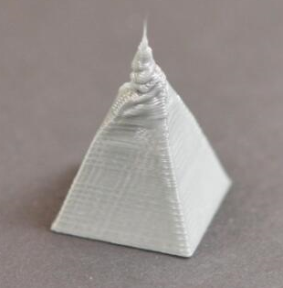

Insufficient heat dissipation
The most common cause of overheating is that plastics have not cooled down in time. When cooling is slow, plastic can easily be changed in shape. For multiple plastics, it is better to quickly cool the printed layers to prevent them from deforming. If you have a cooling fan on your printer, try increasing the fan's power to make the plastic cool faster. The speed of the fan can be adjusted. In the upper corner of the screen, a fan speed percentage is displayed. During the printing process, the speed can be adjusted within the control. The fastest speed is 255. After the general model prints the bottom layer, it will turn on the fan at full speed.
Printing temperature is too high
If you have already used a cooling fan but still have problems, you may need to try to lower the print temperature. If the plastic is extruded from the nozzle at a lower temperature, it may solidify faster. Try to reduce the print temperature by 5 to 10 degrees to see the effect. The print temperature of PLA is generally 190-210. If you set the temperature is too high, consumables melt completely out of the nozzle, and then it is more easily deformed when stacked, different manufacturers of supplies printing temperature is not the same, this need to test out the most appropriate print temperature, it will be better to choose the right temperature.
Print too fast

If you print each layer very quickly, it may not allow enough time for the layer to cool properly, but it will start printing new layers on it again. This is particularly important when printing small models because each floor has only a small amount of time to print. Even with a cooling fan, for these very small layers, you still need to reduce the print speed to ensure that there is enough time for the layers to freeze. Fortunately, there is a minimum print time per layer setting in Cura Premium. If you have a small print time per layer, you can set a longer time. This setting is used to automatically print a small layer. Decrease the speed to ensure that they have enough time to cool and solidify when printing the next layer. For example, if you allow, when the printing time is less than 10 seconds, the software adjusts the printing speed, and the program will automatically reduce the printing speed for these small layers. This is a key feature to solve the problem of too hot.

When none of these methods work, try printing multiple prints at once
If you have tried the above three methods, but still have problems with cooling, there is another way, you can try it. Copy the model you want to print or import another model that can be printed at the same time. By printing two models at the same time, you can provide more cooling time for each model. The nozzle will need to move to a different location to print the second model, which provides an opportunity to cool the first model. This is simple, but it is a very effective strategy to solve the problem of overheating.

