Cracking or breaking of layers during 3D printing
3D printing builds a model by printing one layer at a time. Each subsequent layer is printed on the previous layer and finally builds the desired 3D shape. Then, in order to make the final print solid and reliable, you need to make sure that each layer is fully bonded to the layer below it. If the layer does not adhere well to the layer, the final print may crack or break. Next, we will discuss some typical reasons and corresponding solutions.
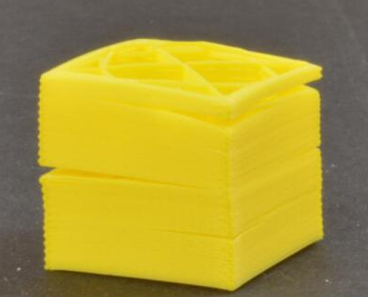

Layer height is too high
Most 3D printer nozzles’ diameter are between 0.2 and 0.6mm. Plastic extrudes from this tiny hole to form a very fine squeezed thread, which can build more printout with rich details. However, these small nozzles also lead to a limitation of the height of the floor. When you print another layer of plastic on one layer, you need to make sure that the new layer is pressed onto the lower layer so that the two layers can stick together. In general, you need to make sure that the layer height you choose is 20% smaller than the nozzle diameter. For example, if your nozzle diameter is 0.4mm, the layer height you use should not exceed 0.32mm, otherwise the plastic on each layer will not bond properly with the layer below it, and the appropriate layer height is generally set at 0.1-0.24. In this way, the surface accuracy of the model is guaranteed, and the adhesion is very good. So, if you find that the print is cracked and there is no bond between the layers, first you need to check that the layer height matches the nozzle diameter. Try reducing the height to see if you can make the layers stick better.
Print temperature is too low
Compared to cold plastics, hot plastics are always better bonded together. If you find that the layers do not adhere well to one another, and you can be sure that the layer height is not set too high, your wire may need to be printed at a higher temperature for better adhesion. For example, if you try to print ABS plastic at 190 degrees Celsius, you may find it easy to separate layers. This is because ABS generally needs to be printed at 230 to 260 degrees Celsius so that the layers and layers are strongly bonded. So if you think this may be the problem, make sure that you buy the correct filament and set the correct print temperature. Try increasing the temperature by 10 degrees Celsius each time to see if the bond has improved.
Print speed is too fast and the wall thickness is too thin
For the same time-to-speed ratio, it is conceivable that there must be a certain difference between the adhesion of model layers printed at a speed of 100 mm/s and the model layers printed at a speed of 50 mm/s at the same time. The same is true for the wall thickness. A wall thickness of 0.4 is comparable to 1.2 mm. A 0.4 mm crack is easy to tear, but 1.2 mm is not so easy. If it is cold in winter, the wall is too thin. Thickness is more easily split.
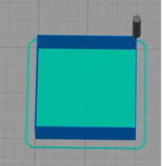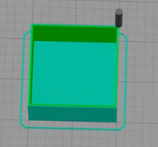
One layer wall thickness Three layer wall thickness
Appropriate print speeds with proper wall thickness and fill can be more effective in avoiding splitting of the model layer.

