Holes and gaps on the corners of the bottom surface in 3D printing
In 3D printing, each layer is built on the previous layer. However, the amount of plastic used for printing will cause the holes and gaps’ problem, so the balance between the strength of the base and the amount of plastic used needs to be balanced. If the foundation is not strong enough, holes and gaps will appear between the layers. Especially in corners with varying sizes (for example, you are printing a 20cm square above a 40cm square). When printing is converted to a smaller size, you need to make sure that there is enough foundation to support the 20mm square wall. There are usually several reasons why the foundation is not strong.
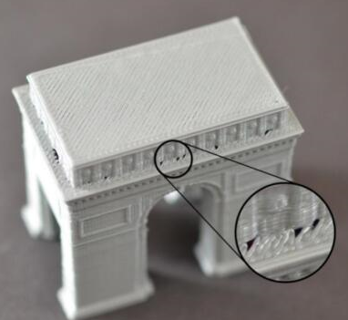

Insufficient number of edges
For printouts, adding more outline edges will significantly enhance the base. Because the inside of the print is usually partially hollow, the thickness of the outer wall is very large, which will affect the printouts. There is a wall thickness setting in the basic setting. The wall thickness setting is generally a multiple times of the nozzle. For example, if your nozzle is 0.4mm, then the wall thickness is generally set between 0.8mm-1.6mm, if you set it 0.8mm at the beginning, but the printed model has a hole in the outer wall, then you can properly increase it by adding one or two layers of wall thickness. The appropriate wall thickness is generally 1.2mm, so it will not be too long and it will be printed out. There are no holes in the model.
Top floor lacks solid layers
Another common reason that causes the foundation is not solid is that the you do not have enough solid fill layers on top of the print.
Too thin upper wall cannot fully support the structure that is struck on it. Modify this setting to basic-fill-bottom/top-layer thickness. If the previous default is 0.8mm but there are still holes in the printout, then you can set the bottom/top thickness at 1.0mmz-1.2mm. In this way, the top and bottom layers can be more closed.
Fill rate is too low
The last setting you need to check is the fill rate, which is controlled by a slider under the “Slice Settings” or “Fill” tab. The top solid layer is built on top of the fill, so it is important to fill enough to support these layers. For example, if you previously set the fill rate to 20%, try increasing this value to 40% to see if the print quality improves.

