Holes and gaps on the corners of the top surface during 3D printing

To save plastics, most 3D printouts consist of a solid shell and a porous hollow core. For example, the filling rate of the core of the printout is only 30%, which means that only 30% of the core is plastic, and the rest is air. Although the inner core of the printout is partially hollow, we hope the surface is solid. To achieve this goal, CURA allows you to set how many solid layers are on the top and bottom of your printout. For example, if you print a block with 5 solid layers on top of each other, the software will print 5 solid layers on top and bottom, but the other middle layers will be partially hollow. This technology can save a lot of plastic and time, but at the same time it can create a solid print. Of course, depending on which settings you use, you may notice that the top layer of the print is not completely solid. As the extruder builds these solid layers, you may see holes or gaps. If you encounter this problem, here are a few simple settings that you can adjust to solve the problem.
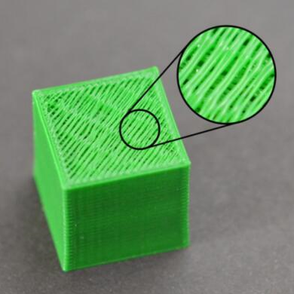
Insufficient solid layer at the top

Adjusting the number of solid filled layers on the top layer is the first to be used. When printing a 100% solid fill layer on a partially hollow filled layer, the solid layer will span the hollow portion of the lower layer. At that time, the plastic extruded on the solid layer tends to droop into the hollow. Therefore, it is usually necessary to print several solid layers on top to obtain a flat and perfect solid surface. It is good practice to print at least 0.5 mm thick on the top solid part. So if you use 0.25 for layer height, you need to print 2 layers of solid top layer. If you print a lower height, say 0.1mm, you need to print 5 solid layers on top to achieve the same effect. If you find a gap between extruded filaments on the top layer, the first thing is to try increasing the number of solid layers on top. For example, if you find this problem and only print 3 top solid layers, try printing 5 solid layers to see if there is any improvement. Note that increasing the solid layer will only increase the volume of plastic inside the printout but will not increase the outside size. You can adjust the thickness of the bottom layer in the basic to improve.

Fill rate is too low

The fill inside the print will become the basis of its upper layer. The solid layer at the top of the printout needs to be printed on this basis. If the fill rate is very low, there will be a lot of empty space in the fill. For example, if you only use a 10% fill rate, the remaining 90% of the printouts will be hollow. This will result in a solid layer that needs to be printed on a very large hollow gap. If you have tried increasing the number of solid layers on the top and you still see the gap at the top, you might try increasing the fill rate to see if the gap will disappear. For example, your fill rate, which was previously set to 30%, is trying to use a 50% fill rate because it provides a better basis for printing the top solid layer.

Insufficient material

If you have tried increasing the fill rate, and the number of solid layers on top, but on the top of the printout, you can still see the gap. Then you may have problems with lack of extrusion. This means that the nozzle does not have to extrude the expected amount of plastic in the software. For a complete solution to this problem, refer to the section on “under-extrusion”.

