How 3D printing fills the gap between the outline
Reorganizing prints consists of outlines along edges and fills. The trailing edge of the contour constitutes a sturdy and precise outer surface of the print. The padding is printed on the inside of the edge and is used to fill the remaining space in the layer. It is usually filled with fast round trip textures, which print faster. Filled with different textures, it is important that the outline of the print is firmly bonded to the two parts of the fill. If you find that there is a gap at the edge of the fill, there are several settings here that you need to check.
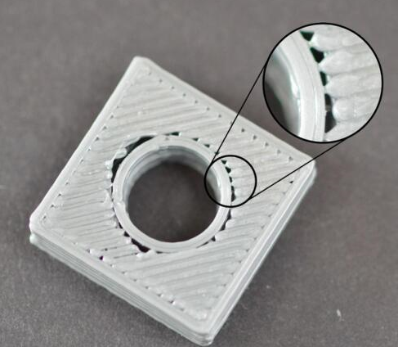

Overlapped contours
There is a setting in CURA that allows you to adjust the bond strength between the outline and the fill. This setting is called "padding coincidence," and it determines how much of the padding will overlap the outline to connect using these two parts. Click "Tools - Open Expert Settings - Fill-Fill Coincidence (%)". This value is based on the percentage of your extruded wire width, so it is easy to expand and adjust for different nozzle sizes. For example, if you set a 20% overlap, this means that the software will command the printer. The fill will overlap 15% with the outermost edge. This overlap helps to ensure that the two parts are strongly bonded. For example, you used 15% overlap before, try increasing to 20% to see if the gap between edge and fill disappears.
Filling prints too fast
Your print fills parts too much faster than the outline. If the fill is printed too fast, it will not have enough time to adhere to the outer contour. If you try to increase the overlap of the outline but still see the gap between the outline and the fill, then you need to reduce the print speed. You can modify the fill-print speed in Advanced. For example, the default above is 0.0. The 0.0 represents the same speed as the print speed is the fill speed, so you can reset the fill print speed, for example, 30mm/s to see if there is any improvement. . Try twice to find the best results.

