How to deal with the 3D printer nozzle jam
Your 3D printer needs to melt and squeeze out several kilograms of plastic during its life cycle. All plastics must be squeezed out through a hole that is only as large as sand, which complicates the problem. Inevitably, something will happened during the process, like the extruder can not push the consumables into the nozzle anymore.
This blockage is often due to something that is in the nozzle that prevents normal extrusion of the consumables. Now we will introduce a couple of single steps to help you dealing with this problem: 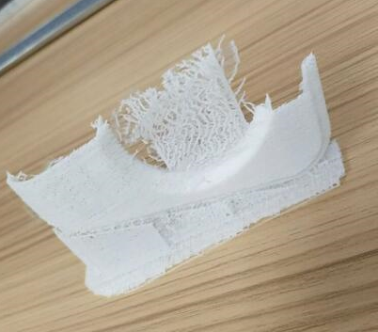

Push the wire manually into the extruder
The first thing you might want to try is manually push the consumables into the extruder. Manually raise the nozzle temperature inside the machine control, the temperature is set at 230 degrees, and when the temperature is reached, then select the moving axis in the preparation - move the 1mm-extruder and squeeze out a small amount of consumables. If it is still not enough, you can turn off the stepper motor and then manually feed it into the nozzle. In most cases, this additional force will allow the wire to pass through the problem location.
Reinstall the wire
If the wire is still not moving, the next thing you have to do is remove the wire. Verify that the extruder temperature is correct, then remove the consumables from the extruder. When the wire is pulled out, use scissors to cut the melted or damaged part of the wire.
Then reinstall the wire and check weather this new wire can be squeezed out without those damages consumables. During this process, you can set the nozzle temperature a little higher to 230 degrees and squeeze it out.
Clear the nozzle
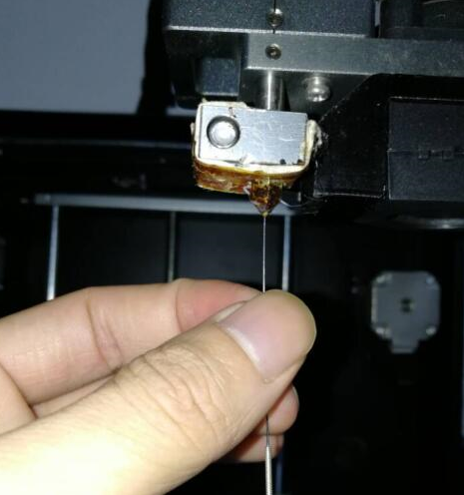

If you cannot extrude this new consumables through the nozzle, you may need to clean the nozzle before operating. Minor plugs can be cleaned with a small needle by raising the nozzle temperature, and then manually fed to the nozzle to resolve. If the plug is severe, then it needs to be replaced and the tube inside the throat should be replaced. If you need to clean the nozzle video can contact us.

