How to solve the linear texture on the side of the print
The appearance of the 3D print consists of hundreds of layers, and if all goes well, these layers will look like an overall smooth surface. Then, if there is a problem with just one layer, it can be clearly seen on the outer surface of the printout that looks like a linear texture. Normally this kind of plutonium occurs periodically, which means that the lines appear regularly (for example, once every 15th layer). Next, several common causes will be discussed.
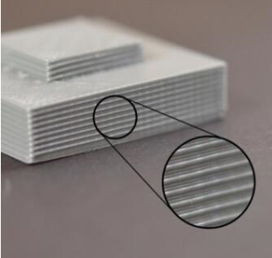

Extrusion instability
The most likely reason for this problem is that the wire quality is not good. If the wire tolerance is large, you will find this change in the outer wall of the printout. For example, if your entire roll of consumables fluctuate by only 5% in diameter, the width of the plastic line extruded from the nozzle will change by 0.05mm. This extra amount of extrusion will cause the corresponding layer to be wider than the other layers and will eventually see a line on the outer wall of the print. To make a smooth surface, your printer needs a stable extrusion condition, which requires high quality consumables. Please read Unsteady Extrusions to learn about other causes of fluctuations.
Temperature fluctuations
Most 3D printers use pins to adjust the temperature of the extruder. If the pins are not properly tuned, the extruder's temperature will fluctuate over time. Given the principle of pin control, this fluctuation will be repeated frequently, which means that the temperature will fluctuate like a sine wave. When the temperature is too high, the plastic extrusion smoothness is different form that when it is colder. This can cause the printer to extrude layers that are different, causing texture on the outer surface of the print. A properly tuned printer should be able to control the temperature of the extruder between plus and minus 5 degrees. The heating block of the CR-2020 machine is wrapped with insulation cotton, which can ensure the stability of the temperature without losing.

