How to solve the problems of plastic wiring and drawing?
When there’s some small plastic remains on the printouts, the drawing exists, this is because the plastic comes out of the nozzle when the nozzle moves to a new position. Fortunately, there are couples of settings in cura can help solve this problem.
The most common way to solve the drawing problem is to "retraction." If retraction is on, then when the extruder finishes printing an area of the model, the wire in the nozzle will be pulled back so that when the print is reprinted, the plastic will be pushed back into the nozzle and squeezed out of the top of the nozzle. To confirm that retraction is already start, click on "Advanced - Filament".
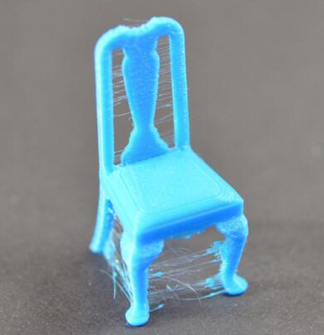
Retraction distance
The most important setting for withdrawal is the withdrawal distance. It determines how much plastic it will pull back from the nozzle. In general, the more plastic that is pulled back from the nozzle, the less likely it is that the nozzle will move when the nozzle moves. The normal withdrawal length is set in the interval of 6-10mm. It also depends on the characteristics of consumables.

Retraction speed

The relevant setting for the next withdrawal is the retraction speed. It determines how fast the filament is pulled from the nozzle. If the retraction is too slow, the plastic will hang from the nozzle, and then begin to leak before moving to a new location. If the retraction is too fast, the wire may be disconnected from the plastic in the nozzle, and even the driving gear may rotate quickly, and the surface portion of the wire may be cut off. The range of the better retraction is between 3600-6000mm/min (60-100mm/s). the exact vale depends on the filament you used. So you need to do some tests to make sure the different speed, and whether reduce the amount of drawing.
The temperature is too high

If you have checked the retraction settings, the next common problem is that the filament drawing because of the extruder’s temperature
If the temperature is too high, the plastic in the nozzle will become very viscous and will flow out of the nozzle more easily. Then, if the temperature is too low, the plastic will remain hard and difficult to squeeze out of the nozzle. If you think that your retraction settings is correct, but this problem still occurs, try reducing the extruder temperature by 5 to 10 degrees. This will have a significant effect on the final print quality. The normal PLA printing temperature is between 190-210. If the temperature is set too high,
the rate of the melted material will cause the retraction to be not clean enough, and it will be easy to draw. Therefore, the proper nozzle print temperature setting is a direct effect on the printing model.
Floating distance is too long

As we discussed above, wire drawing takes place in the extruder and moves between two different positions. Plastic moves from the nozzle during the movement. The length of the moving distance has a great influence on the generation of drawing. The short-range move is fast enough that the plastic does not have time to re-fall from the nozzle. Then, large distance movements are more likely to lead to drawing. This is no way to change in cura. (Note: Fortunately, Simplify 3D includes a very useful feature to make the moving path as small as possible. The software is very smart and can automatically adjust the path of movement to ensure that the distance the nozzle is vacant is very small. In fact, mostly the software can find the right path to avoid moving far away in one minute. This means that there is no possibility of drawing because the nozzle is always above the solid plastic and will not move outside of the printout. Use this Features, click on the "Advanced" tab to open the "to avoid moving out of outline" option, so if you are interested, you can expand on your own, learn to use S3D, of course, if you will be more perfect. If you are interested, you can learn about the use of Simplify3D yourself).

