How to solve the top surface scar in 3D printing
The advantage of 3D printing is that each print builds one layer at a time. This means that each layer is independent and the nozzle can be moved freely to any position on the platform while the print is still under construction. and you may see the nozzle leave traces as it moves on the surface of the previous layer. It is most easily seen on the upper surface of the print. This scar was created by dragging the previously printed plastic over the nozzle as it moved to a new position. Now we will discuss all the reasons and provide some suggestions that which settings can be adjusted to avoid those problems.
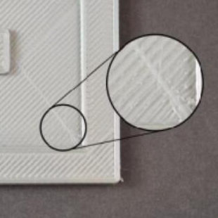

Excessive Consumables extrusion
First you need to make sure that your extruder does not have too much consumables. If it dose, each layer will tend to be thicker than the preset. This means that as the nozzle moves through each layer, it can drag over the previously extruded plastic. Before you check other settings, you need to make sure that you have not extruded too much plastic. Please refer to the "Excessive Extrusion" section for more details.
Lift vertically (Z lift)
If you are sure that the extruder is extruding the correct amount of plastic but you still encounter problems with the nozzle dragging on the top surface, then you need to look at the vertical lift settings in the CURA. Turning on this option will cause the nozzle to lift up a distance before moving above the previously printed layer. When it reaches the target position, the nozzle will return to its original height ready for printing. By moving up a certain height, the nozzle can be prevented from scratching the upper surface of the print. To enable this feature, click Tools - Open Expert Settings –Retraction, and there is a “Z axis lift height”, typically set at about 0.5mm. For example, if you enter 0.5mm, the nozzle will always lift 0.5mm before moving to a new position. Please note that ascent will only occur during withdrawal.

