Solution for stopping extrusion in the middle of 3D printing
If your printer is squeezing out at the beginning, but then suddenly stops extruding, there are usually some factors that may cause this problem. We will explore common causes one by one and provide suggestions for solving problems. If your printer has problems extruding at the beginning, please refer to "No Consumables Extruded After Printing Starts".
Supplies exhausted
This situation is obvious. However, when checking other problems, first make sure if any consumables are sent to the extruder. If the wire runs out of wire, you need to install a new roll of consumables before you start printing.
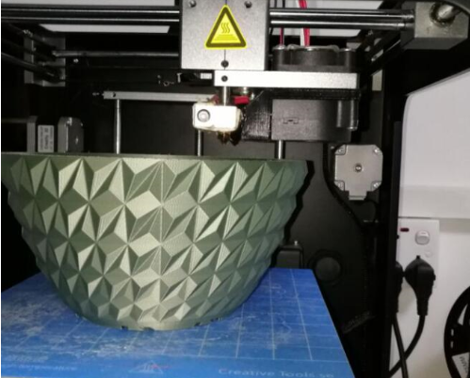

Wire and drive gear skid
During the printing process, the extruder's motor constantly rotates to push the wire into the nozzle so that your printer can continue to extrude the consumables. If you try to print too fast, or you try to squeeze too much consumables, it may cause the motor to cut off the wire until the drive gear cannot catch the wire. If the extruder motor is spinning but the wire does not move, then this is probably the reason. Clogged nozzle
If it is not in any of the situations, it is most likely that the nozzle is clogged. If this happens during the printing process, you may need to check to make sure the wire is clean and there is no dust on the wire roll. Sticking enough dust on the wire may cause it to block the print head during printing. There are other possible causes for nozzle clogging. Please refer to the “Nozzle Clogging” section for more information.
Extruder motor drive overheated
During the printing process, the motor load of the extruder is very large. It continues to rotate back and forth, pulling the wire forward and backward. These fast movements require a lot of current. If the printer's circuitry does not dissipate heat effectively, it may cause the motor drive circuit to overheat. This kind of motor drive usually has overheating protection. When the temperature is too high, it will make the motor stop working. When this happens, the motors of the XY axis will rotate and move the nozzle, but the motor of the extruder will not move at all. The only way to solve this problem is to turn off the printer so that the circuit can cool down. If the printing time is long, you can let the machine take an appropriate rest for an hour after printing to reduce the temperature of the motherboard.

