The 3d consumables can not adhered to the platform
It is very important that the first layer of printing is closely adhered to the platform. Only in this way can the next layers be constructed on this basis. If the first layer fails to stick to the platform, it will cause problems in the later layers. There are many ways to deal with the first layer of non-stick problem.

Construction platform is not horizontal
Many printers have several screws or handles to adjust the position of the platform. If your printer has an adjustable platform and you have problems with the first floor not being on the platform, then the first thing you need to make sure is that your platform is not flat and the placement is horizontal. If it is not level, one side of the platform will be closer to the nozzle while the other side is too far away. The first layer is perfect for printing and requires a horizontal platform.
Adjust the distance between the platform and the nozzle by adjusting the four spring nuts under the platform. The proper distance is that the nozzle just touches the platform. Turn the nozzle counterclockwise away from the platform and turn the nozzle clockwise to fix the platform.

The nozzle platform is too far

After the platform has been leveled, you still need to make sure that the starting position of the nozzle and the spacing from the platform are appropriate. You need to position the nozzle to a suitable distance from the platform, if you hope thes filament stick lightly on the platform to get enough adhesion.
You want the wire to stick lightly on the platform to get enough adhesion.
The first layer prints too fast

When the extruder prints the first layer on the platform, you want the first layer of plastic to stick properly to the surface of the platform so that the other layers can be printed next. If the first layer prints too fast, the plastic may not stick to the platform sufficiently enough. For this reason, a very common method is to reduce the printing speed of the first layer. CURA provides a setting specifically for this feature. Click Advanced, and the Speed option has an underlying print speed that can be set to 20mm/s. Adequate printing time can make the consumables stick to the platform better, and the silk material is sufficient, and the printing is more stable afterwards, and it is not easy to fall off. The appropriate state of the first layer is that the filaments from the nozzle are flat on the platform, and this effect is the best.
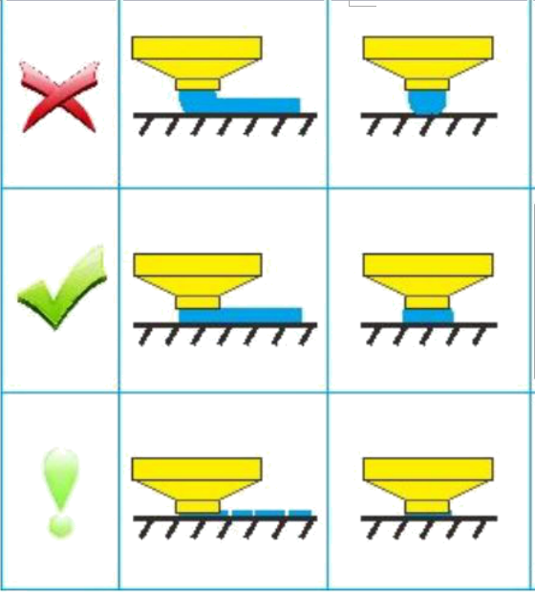
Problem with temperature or cooling settings
When the temperature decreases, the plastic shrinks. To be more clearly, think about a 100-mm-wide abs plastic printout. The extruder prints at 230 degrees, but the platform is cold, and the plastic cools as it exits the nozzle. Some printers also have cooling fans that speed up the cooling process when they start. If this ABS print is cooled to room temperature by 30 degrees, this 100mm wide print will shrink by 1.5mm! However, the platform on your printer will not shrink so much because it is always at the same temperature. Because of this phenomenon, plastics always tend to disengage from the platform when they cool. When printing a layer, this is a very important factor to remember. If you observe that the first layer seems to quickly stick to the platform, but later with the temperature dropped, and then again, then it is likely to be the temperature and cooling-related settings. In order to print plastics like ABS that require high temperatures to melt, many printers have an add-on platform to deal with this problem. During the printing process, if the platform is heated and kept at 110 degrees, it will keep the first layer hot and will not shrink. It is generally believed that PLA heats the bed to 60 to 70 degrees, it will be very good implantation, and ABS at 100 to 120 degrees, it is better. You can modify this setting in CURA, there is a speed/temperature bar in the base; you can change the hot bed temperature to match the conditions you need for your printed supplies. This is a setting for adjusting the hot bed board. There is also a fan setting. If you print ABS supplies that do not require a fan at all, there is a cooling option in Advanced. Turn the fan speed off to turn off the model cooling fan on the side. If it is to print PLA consumables, then the impact of this fan is not so great, but generally the first floor will not be opened, this can be set in the ellipsis behind the fan cooling to set a specific fan opening height.
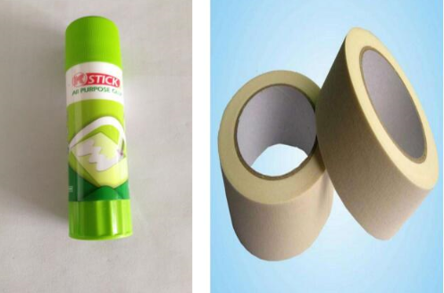
Different plastics have different adhesion to different materials. The machine platform is made of glass fiber board. The plane of the glass fiber board is relatively smooth. Consumables are difficult to stick on such a smooth surface. Therefore, the following auxiliary facilities are needed to make the consumables more firmly bonded to the platform. . First, there are several types of adhesive tapes that can be used to bond with commonly used 3D printing consumables. The strips of tape can be easily glued to the surface of the platform and can also be easily removed or replaced to accommodate printing of different consumables. For example, PLA can bond well with white textured tape. Second, the solid glue, PVP glue on the glass platform evenly coated layer can make the consumables a better platform to bond together, and cleaning with water is very convenient.

