The solution to under-extrusion
Cura includes some settings to determine how much plastic the 3D printer can squeeze out. Then the 3D printer did tell how much plastic actually flowed out of the nozzle. Therefore, it is possible that the actual extruded plastic is less desirable than the software (so-called under-extrusion). If this happens, you may notice that there is a gap between adjacent layers. To test your printer, whether to squeeze enough of it is to print a simple 20mm square cube and set to print at least 3 layers of edges. Check that the three edges at the top of the box are tightly glued together. If there are gaps between the three links, then you are experiencing problems with insufficient material. If these three edges are close to each other and there is no gap, then you may encounter another problem.
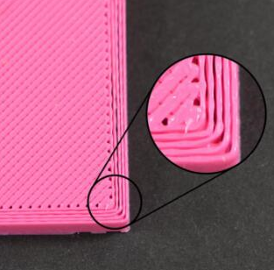
Incorrect nozzle aperture
The machine's own nozzle is 0.4, sometimes you may think that printing may take a long time, and sometimes the customer may not need too much precision. What you need is a model's appearance, so sometimes you will replace a large aperture yourself. The nozzle, but will forget to change the size of the nozzle on the slice, causing the actual discharge to be less than the calculated material, resulting in a gap in the middle. At this time, the actual hole diameter of the nozzle can be changed.

Increase the extrusion rate
If your aperture diameter is correct, but you still see the problem of insufficient material, then you need to adjust the extrusion ratio. This is a very useful setting in CURA that allows you to easily modify the extrusion output (also known as flow rate). There is a print material in the basic inside, which has an extrusion volume setting (%). The default extrusion rate is 100. If the model has insufficient extrusion, it can be appropriately increased to make up for it. In the printing process can also be set in the adjustment inside, adjust there is a FLOW setting, this is the setting of the extrusion ratio.

