The solutions to help with the extrusion instability
To make your 3D printer print high-accuracy models, the extruder needs to extrude the plastic stably. In different parts of the prints, there is a change in the extruded thread, which will affect the final print quality. By carefully observing the printing process, you can identify problems with extrusion instability. For example, if the printer can prints a 20mm long line, but you find that the extruded wire looks rough, or if the size seems to fluctuate, you may have encountered this problem. We have excerpted and squeezed out of instability for several common reasons and described how to avoid it.
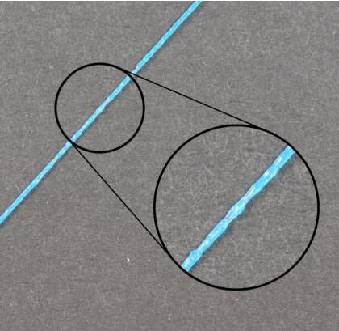

Wire is stuck or twisted together
The first thing you need to check is your printer's supply consumable roll. You need to make sure that the consumable roll can rotate smoothly and the plastic wire can be easily pulled out of the roll. If the wire is messy, or the resistance to free rotation of the consumable roll is too large, this will affect the filament smooth extrude from the nozzle. Check whether the pouring pipe is inserted completely. You need to check if the wire can pass through the pipe smoothly and the resistance is not too high. If the resistance in the tube is too high, you need to try to clean a tube and insert the tube into the bottom of the nozzle.
Plug
If the filament is not jammed, the extruder can be easily pushed, then you need to check is the nozzle itself. Then there may be tinny debris, or other objects come into the nozzle, preventing the normal extrusion. The way to test this possibility is to manually raise the temperature a bit on the machine and manually squeeze some plastic out of the nozzle. Observe that the plastic extrusion is smooth and stable. If you find out the problem, you may need to clean the nozzle. Contact your printer supplier for the correct method of cleaning the inside of the nozzle.
The layer height is too small
If the filament runs smoothly and the extruder is not blocked, it may be useful to check some settings in the cura section. For example, if you are trying to print a very small layer height, such as 0.05mm, then there will be only a tinny space for plastic extrusion nozzles. There is only a 0.05mm gap below the nozzle, which means that the filament may be difficult to squeeze out. Repeatedly confirmed that you used a suitable layer height for your printing. In Basic-Quality-Layer Height, if you are printing with a very small layer height, try increasing the layer height to see if the problem is solved.
Extruder mechanical failure
If you check all the above conditions but still have problems with extrusion instability, then you may need to check your extruder to see if there’s any mechanical problems. For example, many extruders use drive gears with sharp teeth that can get the filament in more flexible. And this makes it easier for the extruder before and after pull and retraction filament.
This kind of extruder can usually adjust the gear pressure on the filament. If set too big, the drive gear will not get the filament in sufficiently deep, which will affect the ability of the extruder to accurately control the position of the filament.

