3D printer details can not be printed out
There’s a fixed-size nozzle that you can use to precisely print very fine details.
For example, many printers have a 0.4 mm diameter open orifice nozzle. This is sufficient when printing many pieces, but you will encounter problems when printing extremely fine details that are smaller than the nozzle diameter. For example, you try to print 0.2mm thin walls with a 0.4mm nozzle. The problem is that you can't accurately get the 0.2mm of extruded filament from a 0.4mm extruder. The width of the extruded filament must always be larger or equal to the diameter of the nozzle. Therefore, when you open the "layer preview" in CURA, you will find that the software deletes the subtle features. The software tells you that you cannot print this subtle feature because of the current nozzle. if you often print subtle details, this will be a problem you often encounter. There are several options that allow you to successfully print this subtle detail. Next, we introduce one by one.
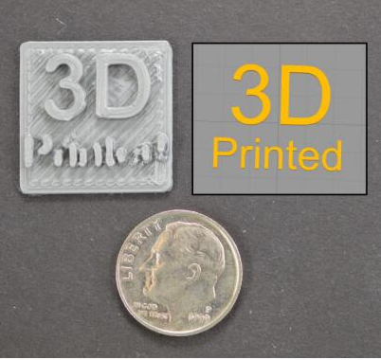

Redesign a thin-walled model
The most obvious choice is to redesign your model to include only features that are larger than your nozzle diameter. Usually this involves editing a 3D model in a CAD file to modify the size of the subtle features. After you increase the thickness of the subtle feature, you can re-import the model into CURA to check if your printer can print the 3D shape you created. If the feature is visible in preview mode, the printer can print the modified feature.
Install nozzle with smaller opening diameter
Most of the time, you can't directly edit the original 3D model. For example, it can be designed by other people or downloaded from the Internet. At this moment, you need to consider the second nozzle for your printer to print subtle features. In most printers, the nozzles are detachable, which makes it easier to adjust after the purchase. For example, you can buy a 0.3mm and a 0.5mm nozzle at the same time, so there will be two options for you.

